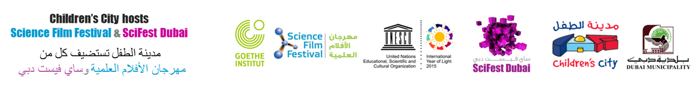

Dear Parents,
Children’s City hosts Science Film Festival and SciFest Dubai 2015
Children’s City hosts Science Film Festival and SciFest Dubai from 4th to 9th October 2015 at their venue in Creek Park, Dubai, Gate 1.
The Science Film Festival, in its 3rd year, presents an international selection of 13 films dedicated to a wide range of important scientific questions and focused especially on this year’s theme LIGHT. All films are translated and synchronized into Arabic and/or English. The films will be complemented with experiments, hands on activities and games to explain and re-enact the scientific correlations.
SciFest Dubai, in its 2nd year, brings an exciting programme of 200+ events in English and Arabic that suits all age groups. SciFest Dubai celebrates science through art and culture, so in addition to science shows, workshops, talks, panel discussions, and debates, there are also science-themed art events, like an astronomy art exhibition, play, performance poetry and much more!
All the events at the science festival are free. However, the Dubai Municipality entrance charge to the Creek Park and Children’s City is AED15 per student (for groups smaller than 20 in number) and AED 20 per student (for groups larger than 20 in number).
Yours sincerely,

---------------------------------------------------------------------------------------------------------------------------------
Consent Form
I, parent/guardian of
Name of Student:_______________________ Year group:____________________________
Give my child permission to attend the Science Festival trip being organised by the School on
Date:_______________________ Time:____________________________
I am aware that there is entrance fee charged by Dubai Municipality. I enclose AED____________
Please give details of any allergies/medical issues that your child may have that the school should be aware of :

Signature of parent/guardian:_______________________ Date:_________________

